Practical:1b

using System;

using System.Collections.Generic;

using System.Linq;

using System.Web;

using System.Web.Services;

namespace wspractical1

{

/// <summary>

/// Summary description for WebService2

/// </summary>

[WebService(Namespace = "http://tempuri.org/")]

[WebServiceBinding(ConformsTo = WsiProfiles.BasicProfile1_1)]

[System.ComponentModel.ToolboxItem(false)]

// To allow this Web Service to be called from script, using ASP.NET AJAX, uncomment the following line.

// [System.Web.Script.Services.ScriptService]

public class WebService2 : System.Web.Services.WebService

{

[WebMethod]

public string HelloWorld()

{

return "Hello World";

}

[WebMethod]

public double squre(double f)

{

return f*f;

}

}

}

Output:

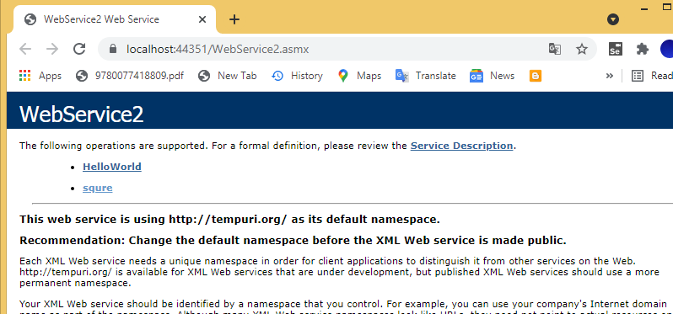

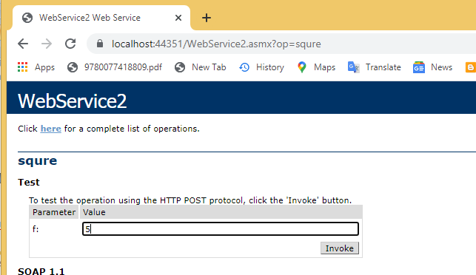

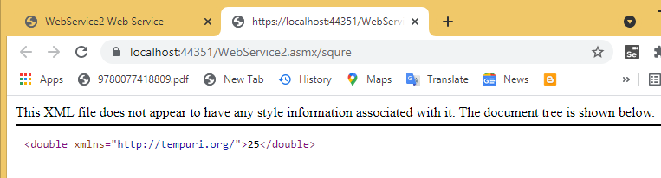

Webform1

<%@ Page Language="C#" AutoEventWireup="true" CodeBehind="WebForm2.aspx.cs" Inherits="wspract1.WebForm2" %>

<!DOCTYPE html>

<html xmlns="http://www.w3.org/1999/xhtml">

<head runat="server">

<title></title>

</head>

<body>

<form id="form1" runat="server">

<div>

<div style="width: 256px">

enter value</div>

</div>

<p>

<asp:TextBox ID="TextBox1" runat="server"></asp:TextBox>

</p>

<p>

<asp:Button ID="Button1" runat="server" OnClick="Button1_Click" Text="calculate" />

</p>

<p>

<asp:TextBox ID="TextBox2" runat="server"></asp:TextBox>

</p>

</form>

</form>

</body>

</html>

Webform1.cs

using System;

using System.Collections.Generic;

using System.Linq;

using System.Web;

using System.Web.UI;

using System.Web.UI.WebControls;

namespace wspract1

{

public partial class WebForm2 : System.Web.UI.Page

{

protected void Page_Load(object sender, EventArgs e)

{

}

protected void Button1_Click(object sender, EventArgs e)

{

WebService1 ws = new WebService1();

TextBox2.Text = ws.squre(Convert.ToDouble(TextBox1.Text)).ToString();

}

}

}

